Banning straw-pros
- British government announced that 850m starws are wasted annually from U.K.
- It doesn’t disappear(rot) for 500years.
- Threat animals
- 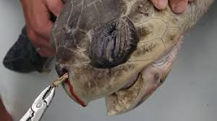
solution
- Biodegradable Straws.
Biodegradation : A process by which microbial organisms transform or alter (through metabolic or enzymatic action) the structure of chemicals introduced into the environment
Cornstarch, coffee power, wheat hay (dry grass) can be sources of straws.
For example, https://www.haystraws.com/products/hay-straws-100-pack
Hay! Straws makes straws with wheat hay.
Also cheap

